Shah Md. Tasrif Rahman

* Encoding: UTF-8.

* Messed this one up on the first time of submission, now Imma redo allat again ah.

* Task-1 [Data importing/loading]:

GET DATA
/TYPE=XLSX
/FILE='E:\Statistical Softwares\SPSS\CUSPC-SPSS\Assignments\Assignment-1\week1_data.xlsx'
/SHEET=name 'Sheet1'
/CELLRANGE=FULL
/READNAMES=ON
/DATATYPEMIN PERCENTAGE=95.0
/HIDDEN IGNORE=YES.
EXECUTE.
DATASET NAME DataSet1 WINDOW=FRONT.

* Task-2 [Data saving]:

SAVE OUTFILE='E:\Statistical Softwares\SPSS\CUSPC-SPSS\Assignments\Assignment-1\assignment1_Shah_Md._Tasrif_Rahman\assignment1_data_Shah_Md._Tasrif_Rahman.sav'
/COMPRESSED.

* Task-3 [Defining variables]:

DATASET ACTIVATE DataSet1.
* Define Variable Properties.
*student_id.
VARIABLE LEVEL student_id(NOMINAL).
VARIABLE LABELS student_id 'Student identification number'.

*gender.
VARIABLE LABELS gender 'Gender of respondent'.
VALUE LABELS gender
'1 ' 'Male'
'2 ' 'Female'.

* This following part is redundant since in the given dataset, the "faculty" column already has the names of the faculties, instead of numbers representing them.

*faculty.
*VARIABLE LABELS faculty 'Faculty of enrolment'.
*VALUE LABELS faculty
'Science' '1'
'Business' '2'
'Arts' '3'
'Engineering' '4'.

*year_of_study.
VARIABLE LEVEL year_of_study(SCALE).
VARIABLE LABELS year_of_study 'Current academic year'.

*study_hours_week.
VARIABLE LABELS study_hours_week 'Self-reported study hours per week'.

*sleep_hours.
VARIABLE LABELS sleep_hours 'Average hours of sleep per night'.

*attendance_pct.
VARIABLE LABELS attendance_pct 'Class attendance (percentage)'.

*stress1.
VARIABLE LEVEL stress1(ORDINAL).
VARIABLE LABELS stress1 'I feel overwhelmed by coursework'.
VALUE LABELS stress1
1 'Strongly disagree'
2 'Disagree'
3 'Neutral'
4 'Agree'
5 'Strongly agree'.

*stress2.
VARIABLE LEVEL stress2(ORDINAL).
VARIABLE LABELS stress2 'I worry about exams'.
VALUE LABELS stress2
1 'Strongly disagree'
2 'Disagree'
3 'Neutral'
4 'Agree'
5 'Strongly agree'.

*stress3.
VARIABLE LEVEL stress3(ORDINAL).
VARIABLE LABELS stress3 'I find it hard to relax'.
VALUE LABELS stress3
1 'Strongly disagree'
2 'Disagree'
3 'Neutral'
4 'Agree'
5 'Strongly agree'.

*stress4.
VARIABLE LEVEL stress4(ORDINAL).
VARIABLE LABELS stress4 'I feel tense about deadlines'.
VALUE LABELS stress4
1 'Strongly disagree'
2 'Disagree'
3 'Neutral'
4 'Agree'
5 'Strongly agree'.

*stress5_calm.
VARIABLE LEVEL stress5_calm(ORDINAL).
VARIABLE LABELS stress5_calm 'I feel calm and in control (REVERSE-WORDED)'.
VALUE LABELS stress5_calm
1 'Strongly disagree'
2 'Disagree'
3 'Neutral'
4 'Agree'
5 'Strongly agree'.

*gpa.
VARIABLE LABELS gpa 'Grade point average (0.00 - 4.00)'.
EXECUTE.

* Task-4 [Recoding gender column and checking consistency]:

DATASET ACTIVATE DataSet1.
RECODE gender ('1'='Male') ('Male'='Male') ('male'='Male') ('M'='Male') ('2'='Female')
('Female'='Female') ('female'='Female') ('F'='Female').
EXECUTE.

DATASET ACTIVATE DataSet1.
RECODE gender ('Male'='1') ('Female'='2').
EXECUTE.
VARIABLE LEVEL gender(SCALE).
VARIABLE LABELS gender 'Gender of respondent'.
VALUE LABELS gender
'1 ' 'Male'
'2 ' 'Female'.
EXECUTE.

FREQUENCIES VARIABLES=gender
/STATISTICS=RANGE MINIMUM MAXIMUM STDDEV MEAN MEDIAN
/FORMAT=NOTABLE
/ORDER=ANALYSIS.

Frequencies

[DataSet1] E:\Statistical Softwares\SPSS\CUSPC-SPSS\Assignments\Assignment-1\assignment1_Shah_Md._Tasrif_Rahman\assignment1_data_Shah_Md._Tasrif_Rahman.sav

Statistics
Gender of respondent
N | Valid | 302
N | Missing | 0

FREQUENCIES VARIABLES=year_of_study
/STATISTICS=RANGE MINIMUM MAXIMUM STDDEV MEAN MEDIAN
/FORMAT=NOTABLE
/ORDER=ANALYSIS.

Frequencies

Statistics
Current academic year
N | Valid | 302
N | Missing | 0
Mean |  | 2.49
Median |  | 3.00
Std. Deviation |  | 1.065
Range |  | 3
Minimum |  | 1
Maximum |  | 4

FREQUENCIES VARIABLES=study_hours_week
/STATISTICS=RANGE MINIMUM MAXIMUM STDDEV MEAN MEDIAN
/FORMAT=NOTABLE
/ORDER=ANALYSIS.

Frequencies

Statistics
Self-reported study hours per week
N | Valid | 289
N | Missing | 13
Mean |  | 13.648
Median |  | 13.800
Std. Deviation |  | 4.7901
Range |  | 25.2
Minimum |  | 1.0
Maximum |  | 26.2

FREQUENCIES VARIABLES=sleep_hours
/STATISTICS=RANGE MINIMUM MAXIMUM STDDEV MEAN MEDIAN
/FORMAT=NOTABLE
/ORDER=ANALYSIS.

Frequencies

Statistics
Average hours of sleep per night
N | Valid | 284
N | Missing | 18
Mean |  | 7.689
Median |  | 6.800
Std. Deviation |  | 9.5156
Range |  | 95.5
Minimum |  | 3.5
Maximum |  | 99.0

FREQUENCIES VARIABLES=attendance_pct
/STATISTICS=RANGE MINIMUM MAXIMUM STDDEV MEAN MEDIAN
/FORMAT=NOTABLE
/ORDER=ANALYSIS.

Frequencies

Statistics
Class attendance (percentage)
N | Valid | 287
N | Missing | 15
Mean |  | 78.616
Median |  | 77.800
Std. Deviation |  | 18.6163
Range |  | 207.9
Minimum |  | 42.1
Maximum |  | 250.0

FREQUENCIES VARIABLES=gpa
/STATISTICS=RANGE MINIMUM MAXIMUM STDDEV MEAN MEDIAN
/FORMAT=NOTABLE
/ORDER=ANALYSIS.

Frequencies

Statistics
Grade point average (0.00 - 4.00)
N | Valid | 302
N | Missing | 0
Mean |  | 3.6625
Median |  | 3.8000
Std. Deviation |  | .38073
Range |  | 1.76
Minimum |  | 2.24
Maximum |  | 4.00

* Task-5 [Fixing missing values]:

MISSING VALUES sleep_hours (99)
EXECUTE.

Error # 701 in column 1. Text: EXECUTE
An undefined variable name, or a scratch or system variable was specified in a
variable list which accepts only standard variables. Check spelling and
verify the existence of this variable.
Execution of this command stops.

Error # 4816. Command name: MISSING VALUES
The variable list on the MISSING VALUES command was incorrect.

Error # 4810 in column 1024. Text: (End of Command)
The parenthesized list of missing values was omitted.
MISSING VALUES attendance_pct (250)
EXECUTE.

Error # 701 in column 1. Text: EXECUTE
An undefined variable name, or a scratch or system variable was specified in a
variable list which accepts only standard variables. Check spelling and
verify the existence of this variable.
Execution of this command stops.

Error # 4816. Command name: MISSING VALUES
The variable list on the MISSING VALUES command was incorrect.

Error # 4810 in column 1024. Text: (End of Command)
The parenthesized list of missing values was omitted.

* Task-6 [Finding and removing duplicate observations]:

* Identify Duplicate Cases.
SORT CASES BY student_id(A).
MATCH FILES
/FILE=*
/BY student_id
/FIRST=PrimaryFirst
/LAST=PrimaryLast_sorted_by_student_id.
DO IF (PrimaryFirst).
COMPUTE MatchSequence=1-PrimaryLast_sorted_by_student_id.
ELSE.
COMPUTE MatchSequence=MatchSequence+1.
END IF.
LEAVE MatchSequence.
FORMATS MatchSequence (f7).
COMPUTE InDupGrp=MatchSequence>0.
SORT CASES InDupGrp(D).
MATCH FILES
/FILE=*
/DROP=PrimaryFirst InDupGrp MatchSequence.
VARIABLE LABELS PrimaryLast_sorted_by_student_id 'Indicator of each last matching case as Primary'.
VALUE LABELS PrimaryLast_sorted_by_student_id 0 'Duplicate Case' 1 'Primary Case'.
VARIABLE LEVEL PrimaryLast_sorted_by_student_id (ORDINAL).
FREQUENCIES VARIABLES=PrimaryLast_sorted_by_student_id.

Frequencies

Statistics
Indicator of each last matching case as Primary
N | Valid | 302
N | Missing | 0

Indicator of each last matching case as Primary
 |  | Frequency | Percent | Valid Percent | Cumulative Percent
Valid | Duplicate Case | 2 | .7 | .7 | .7
Valid | Primary Case | 300 | 99.3 | 99.3 | 100.0
Valid | Total | 302 | 100.0 | 100.0

EXECUTE.

* Removing duplicates permanently:

SELECT IF (PrimaryLast_sorted_by_student_id = 1).
EXECUTE.

*There were 2 duplicate cases out of 302 cases, 300 primary cases remain after deduplication.

* Task-7 [Reverse coding and adding stress_total variable]:

COMPUTE stress5_r=6-stress5_calm.
EXECUTE.

COMPUTE stress_total=stress1 + stress2 + stress3 + stress4 + stress5_r.
EXECUTE.

* Task-8 [Checking summary and drawing histogram]:

FREQUENCIES VARIABLES=study_hours_week sleep_hours attendance_pct
/FORMAT=NOTABLE
/STATISTICS=RANGE MINIMUM MAXIMUM MEAN MEDIAN
/HISTOGRAM
/ORDER=ANALYSIS.

Frequencies

Statistics
 |  | Self-reported study hours per week | Average hours of sleep per night | Class attendance (percentage)
N | Valid | 288 | 279 | 283
N | Missing | 12 | 21 | 17
Mean |  | 13.631 | 6.714 | 77.419
Median |  | 13.750 | 6.800 | 77.600
Range |  | 25.2 | 6.5 | 57.9
Minimum |  | 1.0 | 3.5 | 42.1
Maximum |  | 26.2 | 10.0 | 100.0

Histogram

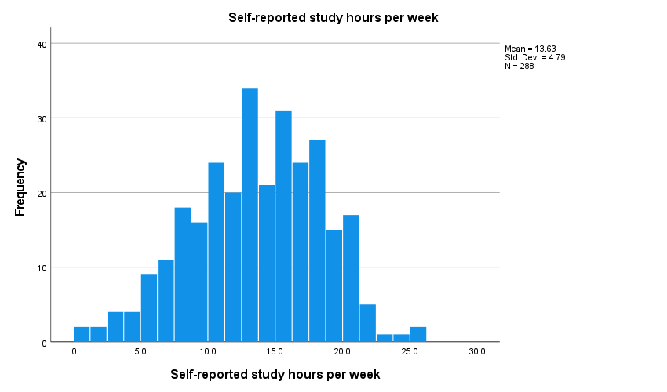

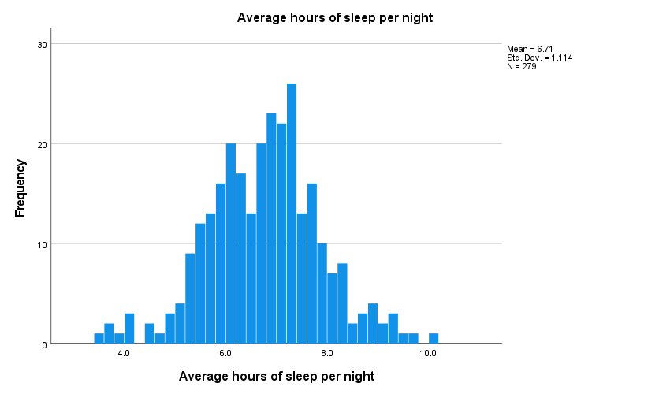

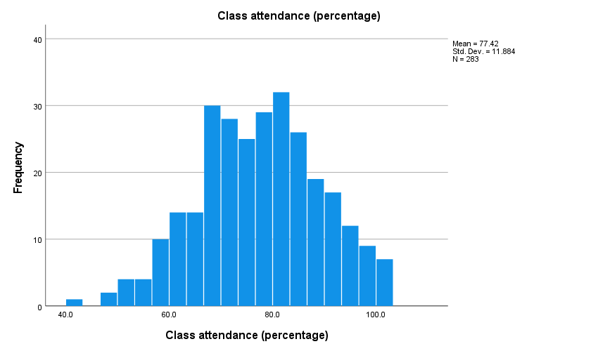

* Task-9 [Checking frequency table and drawing bar chart]:

FREQUENCIES VARIABLES=faculty year_of_study
/BARCHART FREQ
/ORDER=ANALYSIS.

Frequencies

Statistics
 |  | faculty | Current academic year
N | Valid | 300 | 300
N | Missing | 0 | 0

Frequency Table

faculty
 |  | Frequency | Percent | Valid Percent | Cumulative Percent
Valid | Arts | 58 | 19.3 | 19.3 | 19.3
Valid | Business | 76 | 25.3 | 25.3 | 44.7
Valid | Engineering | 77 | 25.7 | 25.7 | 70.3
Valid | Science | 89 | 29.7 | 29.7 | 100.0
Valid | Total | 300 | 100.0 | 100.0

Current academic year
 |  | Frequency | Percent | Valid Percent | Cumulative Percent
Valid | 1 | 70 | 23.3 | 23.3 | 23.3
Valid | 2 | 75 | 25.0 | 25.0 | 48.3
Valid | 3 | 93 | 31.0 | 31.0 | 79.3
Valid | 4 | 62 | 20.7 | 20.7 | 100.0
Valid | Total | 300 | 100.0 | 100.0

Bar Chart

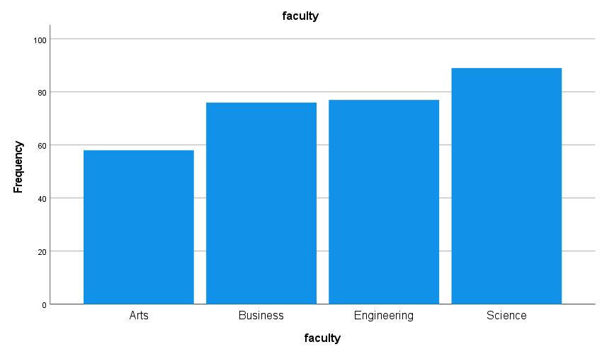

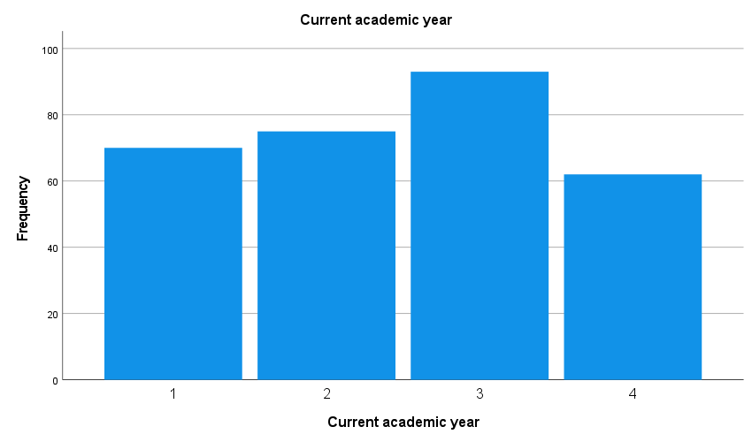

DATASET ACTIVATE DataSet1.

SAVE OUTFILE='E:\Statistical '+
'Softwares\SPSS\CUSPC-SPSS\Assignments\Assignment-1\assignment1_Shah_Md._Tasrif_Rahman\assignme'+
'nt1_data_Shah_Md._Tasrif_Rahman.sav'
/COMPRESSED.

* Task-10 [Exporting output]:

OUTPUT SAVE NAME=Document1
OUTFILE='E:\Statistical '+
'Softwares\SPSS\CUSPC-SPSS\Assignments\Assignment-1\assignment1_Shah_Md._Tasrif_Rahman\assignme'+
'nt1_Shah_Md._Tasrif_Rahman_Output.spv'
LOCK=NO.

* Export Output.
OUTPUT EXPORT
/CONTENTS EXPORT=VISIBLE LAYERS=PRINTSETTING MODELVIEWS=PRINTSETTING
/DOC DOCUMENTFILE='E:\Statistical '+
'Softwares\SPSS\CUSPC-SPSS\Assignments\Assignment-1\assignment1_Shah_Md._Tasrif_Rahman\assignme'+
'nt1_data_Shah_Md._Tasrif_Rahman.doc'
NOTESCAPTIONS=YES WIDETABLES=SHRINK PAGEBREAKS=YES
PAGESIZE=INCHES(8.267000000000001, 11.69) TOPMARGIN=INCHES(1.0) BOTTOMMARGIN=INCHES(1.0)

Appendix:

* Encoding: UTF-8.

* Messed this one up on the first time of submission, now Imma redo allat again ah.

* Task-1 [Data importing/loading]:

GET DATA
/TYPE=XLSX
/FILE='E:\Statistical Softwares\SPSS\CUSPC-SPSS\Assignments\Assignment-1\week1_data.xlsx'
/SHEET=name 'Sheet1'
/CELLRANGE=FULL
/READNAMES=ON
/DATATYPEMIN PERCENTAGE=95.0
/HIDDEN IGNORE=YES.
EXECUTE.
DATASET NAME DataSet1 WINDOW=FRONT.

* Task-2 [Data saving]:

SAVE OUTFILE='E:\Statistical Softwares\SPSS\CUSPC-SPSS\Assignments\Assignment-1\assignment1_Shah_Md._Tasrif_Rahman\assignment1_data_Shah_Md._Tasrif_Rahman.sav'
/COMPRESSED.

* Task-3 [Defining variables]:

DATASET ACTIVATE DataSet1.
* Define Variable Properties.
*student_id.
VARIABLE LEVEL student_id(NOMINAL).
VARIABLE LABELS student_id 'Student identification number'.

*gender.
VARIABLE LABELS gender 'Gender of respondent'.
VALUE LABELS gender
'1 ' 'Male'
'2 ' 'Female'.

* This following part is redundant since in the given dataset, the "faculty" column already has the names of the faculties, instead of numbers representing them.

*faculty.
*VARIABLE LABELS faculty 'Faculty of enrolment'.
*VALUE LABELS faculty
'Science' '1'
'Business' '2'
'Arts' '3'
'Engineering' '4'.

*year_of_study.
VARIABLE LEVEL year_of_study(SCALE).
VARIABLE LABELS year_of_study 'Current academic year'.

*study_hours_week.
VARIABLE LABELS study_hours_week 'Self-reported study hours per week'.

*sleep_hours.
VARIABLE LABELS sleep_hours 'Average hours of sleep per night'.

*attendance_pct.
VARIABLE LABELS attendance_pct 'Class attendance (percentage)'.

*stress1.
VARIABLE LEVEL stress1(ORDINAL).
VARIABLE LABELS stress1 'I feel overwhelmed by coursework'.
VALUE LABELS stress1
1 'Strongly disagree'
2 'Disagree'
3 'Neutral'
4 'Agree'
5 'Strongly agree'.

*stress2.
VARIABLE LEVEL stress2(ORDINAL).
VARIABLE LABELS stress2 'I worry about exams'.
VALUE LABELS stress2
1 'Strongly disagree'
2 'Disagree'
3 'Neutral'
4 'Agree'
5 'Strongly agree'.

*stress3.
VARIABLE LEVEL stress3(ORDINAL).
VARIABLE LABELS stress3 'I find it hard to relax'.
VALUE LABELS stress3
1 'Strongly disagree'
2 'Disagree'
3 'Neutral'
4 'Agree'
5 'Strongly agree'.

*stress4.
VARIABLE LEVEL stress4(ORDINAL).
VARIABLE LABELS stress4 'I feel tense about deadlines'.
VALUE LABELS stress4
1 'Strongly disagree'
2 'Disagree'
3 'Neutral'
4 'Agree'
5 'Strongly agree'.

*stress5_calm.
VARIABLE LEVEL stress5_calm(ORDINAL).
VARIABLE LABELS stress5_calm 'I feel calm and in control (REVERSE-WORDED)'.
VALUE LABELS stress5_calm
1 'Strongly disagree'
2 'Disagree'
3 'Neutral'
4 'Agree'
5 'Strongly agree'.

*gpa.
VARIABLE LABELS gpa 'Grade point average (0.00 - 4.00)'.
EXECUTE.

* Task-4 [Recoding gender column and checking consistency]:

DATASET ACTIVATE DataSet1.
RECODE gender ('1'='Male') ('Male'='Male') ('male'='Male') ('M'='Male') ('2'='Female')
('Female'='Female') ('female'='Female') ('F'='Female').
EXECUTE.

DATASET ACTIVATE DataSet1.
RECODE gender ('Male'='1') ('Female'='2').
EXECUTE.
VARIABLE LEVEL gender(SCALE).
VARIABLE LABELS gender 'Gender of respondent'.
VALUE LABELS gender
'1 ' 'Male'
'2 ' 'Female'.
EXECUTE.

FREQUENCIES VARIABLES=gender
/STATISTICS=RANGE MINIMUM MAXIMUM STDDEV MEAN MEDIAN
/FORMAT=NOTABLE
/ORDER=ANALYSIS.

FREQUENCIES VARIABLES=year_of_study
/STATISTICS=RANGE MINIMUM MAXIMUM STDDEV MEAN MEDIAN
/FORMAT=NOTABLE
/ORDER=ANALYSIS.

FREQUENCIES VARIABLES=study_hours_week
/STATISTICS=RANGE MINIMUM MAXIMUM STDDEV MEAN MEDIAN
/FORMAT=NOTABLE
/ORDER=ANALYSIS.

FREQUENCIES VARIABLES=sleep_hours
/STATISTICS=RANGE MINIMUM MAXIMUM STDDEV MEAN MEDIAN
/FORMAT=NOTABLE
/ORDER=ANALYSIS.

FREQUENCIES VARIABLES=attendance_pct
/STATISTICS=RANGE MINIMUM MAXIMUM STDDEV MEAN MEDIAN
/FORMAT=NOTABLE
/ORDER=ANALYSIS.

FREQUENCIES VARIABLES=gpa
/STATISTICS=RANGE MINIMUM MAXIMUM STDDEV MEAN MEDIAN
/FORMAT=NOTABLE
/ORDER=ANALYSIS.

* Task-5 [Fixing missing values]:

MISSING VALUES sleep_hours (99)
EXECUTE.
MISSING VALUES attendance_pct (250)
EXECUTE.

* Task-6 [Finding and removing duplicate observations]:

* Identify Duplicate Cases.
SORT CASES BY student_id(A).
MATCH FILES
/FILE=*
/BY student_id
/FIRST=PrimaryFirst
/LAST=PrimaryLast_sorted_by_student_id.
DO IF (PrimaryFirst).
COMPUTE MatchSequence=1-PrimaryLast_sorted_by_student_id.
ELSE.
COMPUTE MatchSequence=MatchSequence+1.
END IF.
LEAVE MatchSequence.
FORMATS MatchSequence (f7).
COMPUTE InDupGrp=MatchSequence>0.
SORT CASES InDupGrp(D).
MATCH FILES
/FILE=*
/DROP=PrimaryFirst InDupGrp MatchSequence.
VARIABLE LABELS PrimaryLast_sorted_by_student_id 'Indicator of each last matching case as Primary'.
VALUE LABELS PrimaryLast_sorted_by_student_id 0 'Duplicate Case' 1 'Primary Case'.
VARIABLE LEVEL PrimaryLast_sorted_by_student_id (ORDINAL).
FREQUENCIES VARIABLES=PrimaryLast_sorted_by_student_id.
EXECUTE.

* Removing duplicates permanently:

SELECT IF (PrimaryLast_sorted_by_student_id = 1).
EXECUTE.

*There were 2 duplicate cases out of 302 cases, 300 primary cases remain after deduplication.

* Task-7 [Reverse coding and adding stress_total variable]:

COMPUTE stress5_r=6-stress5_calm.
EXECUTE.

COMPUTE stress_total=stress1 + stress2 + stress3 + stress4 + stress5_r.
EXECUTE.

* Task-8 [Checking summary and drawing histogram]:

FREQUENCIES VARIABLES=study_hours_week sleep_hours attendance_pct
/FORMAT=NOTABLE
/STATISTICS=RANGE MINIMUM MAXIMUM MEAN MEDIAN
/HISTOGRAM
/ORDER=ANALYSIS.

* Task-9 [Checking frequency table and drawing bar chart]:

FREQUENCIES VARIABLES=faculty year_of_study
/BARCHART FREQ
/ORDER=ANALYSIS.

DATASET ACTIVATE DataSet1.

SAVE OUTFILE='E:\Statistical '+
'Softwares\SPSS\CUSPC-SPSS\Assignments\Assignment-1\assignment1_Shah_Md._Tasrif_Rahman\assignme'+
'nt1_data_Shah_Md._Tasrif_Rahman.sav'
/COMPRESSED.

* Task-10 [Exporting output]:

OUTPUT SAVE NAME=Document1
OUTFILE='E:\Statistical '+
'Softwares\SPSS\CUSPC-SPSS\Assignments\Assignment-1\assignment1_Shah_Md._Tasrif_Rahman\assignme'+
'nt1_Shah_Md._Tasrif_Rahman_Output.spv'
LOCK=NO.

* Export Output.
OUTPUT EXPORT
/CONTENTS EXPORT=VISIBLE LAYERS=PRINTSETTING MODELVIEWS=PRINTSETTING
/DOC DOCUMENTFILE='E:\Statistical '+
'Softwares\SPSS\CUSPC-SPSS\Assignments\Assignment-1\assignment1_Shah_Md._Tasrif_Rahman\assignme'+
'nt1_data_Shah_Md._Tasrif_Rahman.doc'
NOTESCAPTIONS=YES WIDETABLES=SHRINK PAGEBREAKS=YES
PAGESIZE=INCHES(8.267000000000001, 11.69) TOPMARGIN=INCHES(1.0) BOTTOMMARGIN=INCHES(1.0)
LEFTMARGIN=INCHES(1.0) RIGHTMARGIN=INCHES(1.0000000000000018).

